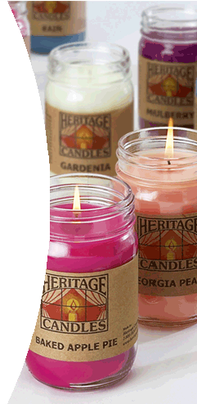
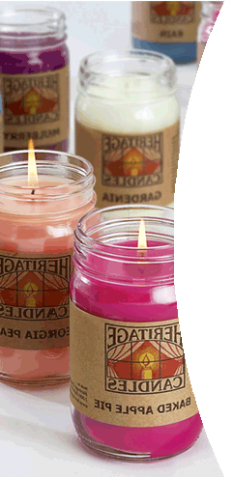
FBLA FUNDRAISER – HERTIAGE CANDLES
Excel Assignment with Chart

- Students will prepare a spreadsheet that uses formulas and inserts a chart.

- Enter the following information into an Excel spreadsheet.

Student Name | Baked  Apple  Pie | Cinnamon | Melon | Mulberry | Sugar  cookie | Vanilla | Georgia  Peach | Total #  Sold | Total  Sales
Mariah Porter | 14 | 2 | 6 | 1 | 3 | 8 | 7
Jalysa McIntyre | 3 | 8 | 4 | 2 | 4 | 5 | 4
Terana Crawford | 2 | 2 | 3 | 2 | 1 | 1 | 4
Ella McBride | 6 | 4 | 3 | 3 | 1 | 1 | 2
Chris Nance | 3 | 2 | 1 | 2 | 2 | 3 | 1
Quamori Goodwin | 5 | 3 | 4 | 2 | 1 | 4 | 3
Nikel Turner | 3 | 1 | 4 | 2 | 2 | 1 | 3
Emani Sewell | 2 | 2 | 1 | 1 | 0 | 0 | 2
Fan Hubbard | 1 | 3 | 4 | 1 | 2 | 2 | 3
Totals
Total Sales of All
Average Sale |  |  |  |  | NOTE: Each candle sells for
Maximum Sale |  |  |  |  | $11.00 each. Members earn
Minimum Sale |  |  |  |  | $5.00 profit per candle for the
# of Candles Sold |  |  |  |  | organization.
Estimated Profit

- Format the spreadsheet, add formulas, and create a chart using the instructions below.
  - Save your file as candle fundraiser.
  - Each candle costs $11.00. FBLA Organization earns $5.00 profit on each candle.
  - Add a creative title to the spreadsheet in A1 and then merge and center over the spreadsheet.
  - Enhance the title by changing the font (your choice) and size to 20pt, bold.
  - Shade the title cells – light yellow.
  - Wrap cells for column headings – ALT+ENTER
  - Center column headings
  - Enter a formula in F to calculate the total number of candles sold by each person.
  - Enter a formula in G to calculate the total number total sales for each person.
  - Use auto sum to calculate the total of each candle scent.
  - Enter a formula to calculate total sales of All.
  - Enter a function to calculate average sale of each member. Format with currency, 2 decimals.
  - Enter a function to calculate maximum sale of each member. Format with currency, 2 decimals.
  - Enter a function to calculate minimum sale of each member.
  - Enter a formula to calculate the number of candles sold. Format with number, no decimals. Format with currency, 2 decimals.
  - Enter a formula to calculate the estimated profit for our FBLA organization. Format with currency, 2 decimals.

- Create a pie chart to show the scent distribution of each candle sold. Add an appropriate chart title. Include the category name and percentage for data label options in the chart. Remove the legend. Save your chart and resize it so that it appears attractively in the spreadsheet document. Make sure the document fits on one page.

- Your FBLA organization set a goal of $1000.00 in sales for this fundraiser to help with SLC costs. How many additional candles would the group need to sell to reach their goal? What if the goal increased to $1200 to include NLC expenses?

